USER GUIDE
BABY MONITOR SM43A
(Digital Wireless Video Baby Monitor With 4.3 inches Color Screen)

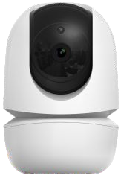
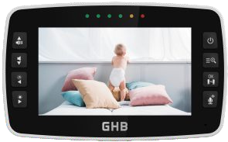
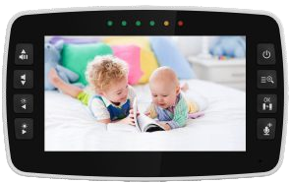

CATCH EVERY PRECIOUS MONENT OF YOUR BABY

VIDEO BABY MONITOR Model: SM4 3A

THANK YOU FOR PURCHASING THIS BABY MONITOR
PLEASE ACTIVE AND EXTEND YOUR WARRENTY NOW

CongratulationI

Now you can take care of your babies anywhere and anytime ! Please read the user manual before you use !
Please retain your original dated sales receipt for your records.
For warranty service of your baby monitor, you will need to provide a copy of your dated sales receipt to confirm warranty status. Registration is not required for warranty coverage.
Before you use the product, we recommend you to fully charge the battery in the parent unit, so that it continues to work even when disconnected from the power supply for transferring to another location.
Please read the Safety instructions.

Please make sure you have the following in this packing.
- Parent unit x 1
- Baby unit x 1 (x 2 in SM43A-2 Model)
- Adapter x 2 (x 3 in SM43A-2 Model)
- User man ual x 1
- Srew set x 1 (x 2 in SM43A-2 Model)

CAUTION: Keep small parts away from children.
Strangulation Hazard: Children can become entangled in cords. Power cords should be kept more than 3 feet away from the crib and baby's reach all the time. Baby monitors and cameras with power cords should never be hung on or near the crib. This product is not a toy and should be kept out of children’s reach. This product contains small parts. Be care when unpacking and assembling the product.
Read and keep instructions: All the safety and operating instructions should be read before the video baby monitor is operated.
This product cannot replace reeponsible adult eupervision.
Water and moisture: This product is designed for indoor use only. The unit should not be exposed to rain, moisture, dripping or splashing. No objects filled with liquid shouId be placed on top of, or beside the product, such as a glass or vase. This item should not be used near water.
DO NOT USE THE APPLIANCE:
-If the cord or plug is damaged.
-If your baby monitor is not operating properly or has suffered any damage.
Contact service: The service center to request inspection and repair it in order to avoid any possible risk.
DO NOT: Attempt to repair or adjust any of the electrical or mechanical functions of the unit since, if you do, the guarantee will be made void. Ventilation: This baby monitor should not be used on a bed, sofa, rug or similar surface that may block the ventilation openings, or be placed in an enclosed area, such as a bookcase or drawer that may impede air flow.

Keep away from sources of heat: This unit shouId not be exposed to direct heat sources such as a candle, replace, radiator, heat register, stove or other appliance that emits heat. The unit should not be left in direct sunlight.
Power source: This unit should onIy be used with the adapter included in this package
Damage requiring service: This unit should be serviced by qualified person nel.

WARNING: IR emitted from this product. Do not stare at operating lamp! CAUTION : RISK OF EXPLOSION IF BATTERY IS REPLACED BY AN

INCORRECT TYPE. DISPOSE OF USED BATTERIES ACCORDING TO THE INSTRUCTIONS.

-02-

  - Package List

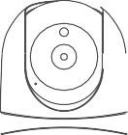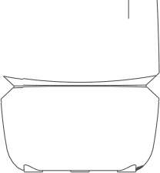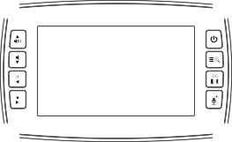

Baby unit x1

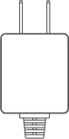
Adapter x2
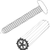
Screw set x1
Parent unit x1
User manual x1

Parent Unit (Monitor)
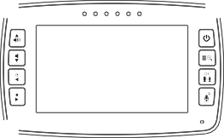
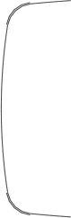


O Power key:
Long press to turn on/off the monitor; short press to screen on/off.
0 Menu / Exit:
Short press Menu/Exit key the menu will pop up, and press again to Exit. Press and hold the Menu/Exit key around 2 seconds to operate Zoom in/out.
G OK key:
Press the OK key to view/scan camera or to confirm.
G Pan&Tilt / Talk to baby:
Short press the key to enter into the pan/Tilt mode.
To talk, press and hold the talk key on the front of the monitor; release to turn it off.
”Bear in mind that you can't listen to your baby while you're talking to them; to listen to it, you wilI have to stop pressing this button.
O Volume + / Up key:
Press Volume+ to increase the volume/ To up the camera in the Pan/Tilt mode.
G Volume - / Down key:
Press Volume- to decrease the volume/ To down the camera in the Pan/Tilt mode.

O Brightness - I Right key:
Press the Brig htness- to decrease the brightness/ To left the camera in the
Pan/Tilt mode.
G Brightness + / Left key:
Press the Brightness+ to increase the brightness/ To right the camera in the Pan/Tilt mode.
G Mie:
When talk to the baby, collect the voices of the parents.
G Power&Charging Indicator LED:
”The LED shows red when charg ing.
”The LED displays shows green after the battery is fully charged.
O Volume LED:
When the baby unit detects the voice, the indicator light wilI be on. The louder the detected sound, the more lights will light up.
G LCD screen:
Display the baby's picture a nd the adjustment of each button function.
G Speaker:
Hear the sound from the baby.
O Stand:
Monitor placement stand.
G Reset key (under the stand):
Long press the reset button with a pin to reset the display.
fi DC-jack:
Charge the monitor by connecting the Power Adapter to the monitor and a socket.
Note:
If you want to adjust the Volume/Brig htness, you have to exit the Pan/Tilt
mode before you operate it.

-O5-

  - Baby Unit(Camera)
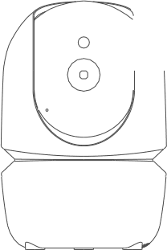
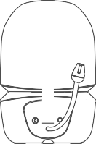
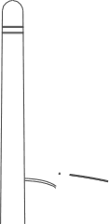

O Light sensor O Infrared LEDs G CMOS sensor G Power LED
G MIC

  - Icons Overview
O Speaker O Pair key
DC-Jack
G Temperature sensor G Antenna

@,iI| Signal | •giiiii Volume | @ Zoom
--- Alarm | -Emu Brightness | - Night vision
---- Lullaby | ECO ECO | - Talk to baby
---- Camera | @Tg Battery | °c/°F Temperature

-06-

  - Charging And Powering The Monitor Unit Step1:
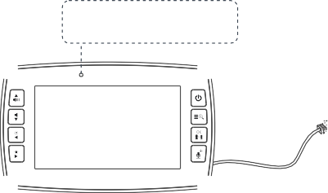
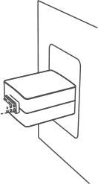
Charge the monitor by connecting the A/C adapter included in this package to the monitor and a socket. (It takes about 4 hours for the monitor to be fully charged).
C harging: Red
Fully charged: Green
Step2:
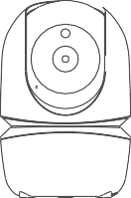
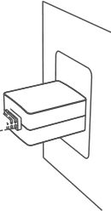
Use the provided AC adapter included in this package to connect the wall outlet with the baby unit.
-07-

Note:
”Place the camera at least 3ft / 1m away from your baby. Gently press and hold the Power Button for 3s to turn on the monitor, then you can see the live view.
”Follow your needs to adjust the sound, brightness, and reasonable placement of the camera.

To use the baby monitor, you must be able to establish a radio link between the monitor and camera, and the range will be affected by en vironmental cond itions:
”Any large metal object, like a refrigerator, a mirror, a filing cabinet,
metallic doors or reinforced concrete between the baby and parent unit may block the radio signal.
”The signal strength may also be reduced by other solid structures, like walIs, or by radio or electrical equipment, such as TV, computers, cordless or mobile phones, fluorescent lights or dimmer switches. “When using the other 2.4GHz product, such as wireless networks (Wi-Fi routers), Bluetooth systems, or microwav e ovens, may cause interference with this product, so keep the baby monitor away at least 5ft(1.5m) from these types of products.

  - Pan And Tilt
The camera unit can be remotel y controlled from the monitor unit Step1. Press the Pan/Tilt key ’ enter the Pan/Tilt mode.
Step2. Press the g „ or to tilt upward or downward .
Step3. Press or to Pan left or right.
Step4. Press the Pan/Tilt key ’ to exit the Pan/Tilt mode.
Note: During the Pan/Tilt mode can not use the navigation key to adjust volume and Brightness.
  - Night Vision Mode
When the built-in photo sensor detects a low level of ambient light, the screen on the monitor unit will display in black and white. the icon will be displayed on the screen.
  - Talk Mode
Press and hold the on the monitor unit to talk to your baby throug h the camera unit's loudspeaker. A '§' icon will be displayed at the bottom right corner of thescreen.

Digital Zoom
Step1. Press and hold the Menu/Exit key Q+ arond 2 seconds enter Zoom mode.
Step2. At the Zoom mode, press the Pan/Tilt key to adjust the direction of the camera/image.
Step3. Press the LEFT key ” to pan left; Press RIGHT key to pan right; Press UP key to tilt up; Press Down key to tilt down.
Step4. Press and hold the Menu/Exit key again around 2 seconds to operate Zoom out. During digital zoom mode, the zoom icon will be displayed on the top of screen.
Warm reminder: If you want to adjust the Volume/Brig htness, you have to exit the Pan/Tilt(press Pan/Tilt key) mode before you operate it.

  - Scan And Switch The Cameras
Press "’ key 2 seconds to view/scan camera, during the scan mode, the @” icon will be displayed on the top of the sceen. Each camera's video will be stay on the LCD around 10 seconds then change to the next camera.
Short press the scan key again to switch the camera under the scan mode. Note: This function is only available when two or more cameras are paired.

4.4 Lullaby Setting
You can soothe the baby to sleep by playing a gentle lullaby from the baby unit.
Step1: Press Menu/Exit key G and the menu will display;


Step2: Press the LEFT key or RIGHT key Step3: Press the UP key \ or DOWN key Step3: Press the UP key or DOWN key Step4: Press OK key "to confirm.
until the lullaby icon is highlighted;
to select the lullaby you need;
to select the Playback time and volume;

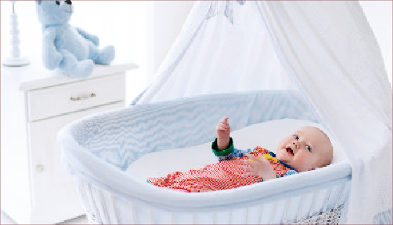

4.2 ECO Mode Setting
This mode allows you to control the sound activation of your baby monitor. When The ECO default setting is on, If there is no sound around the camera within 30 Seconds, the baby unit will stop transmitting signal. The monitor screen turns off when the camera is not transmitting. When the camera detects that the sound is louder than the preset sensitivity level, it will start transmitting the signal to the monitor again.
To change the ECO level, please follow the next instructions: Step1: Press the Menu/Exit key and the menu will display;
Step2: Press the LEFT key or RIGHT key until the ECO icon is highlighted;



Step3: Press the UP key \ or the DOWN key to select the desire level; Step4: Press the OK key ”to confirm.

Note:
LOW --- High volume of sound is required to reactivate the transmission MED --- Medium volume of sound is required to reactivate the transmission HIGH --- Low volume of sound is required to reactivate the transmission
X --- No standby mode
-12-

4£ Feeding Timer Setting
You can use the alarm to remind yourself to feed baby/change diapers/sIeep,etc Step1: Press Menu / Exit key Cfl„ and the menu will display;
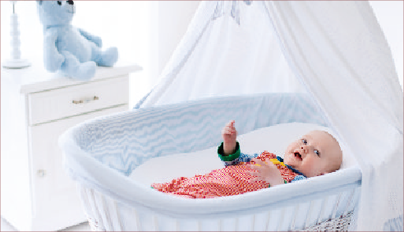




Step2: Press the LEFT key or RIGHT key until the alarm icon is highlighted;
Step3: Press the UP key or DOWN key to select desired alert time;
Step4: Press the OK key ” to confirm.
?,ilI
Note:
If the alarm is ringing and no one answers, then the ring will last for 1 minute; after 3 minutes the ringing will start again.
The alarm will ring for 3 times in total, after this the alarm goes off.
Once the alam is turned on, alam icon will displayed on the Screen. The alarm default setting is OFF.
When the alarm is ringing, press any key on the parent unit to turn the alarm off.

  - Pairing The Camera And Monitor
Step1: Press Menu/Exit key TO+ , then the men u will displa y;

Step2: Press the LEFT key
or RIG HT key
until the PAIR icon is

highlighted, then press UP key to pair;
DOWN key * to select the baby unit

Step3: Press OK key to start the pairing;
Step4: While the LED is flashing, press and hold the PAIR button on the back of the baby unit, once paired, the screen will display the image from the baby unit;
Step5: If failed, please repeat the steps above.






  - Dual View Setting
Step1: Press Menu/Exit key E@ and the menu will display;


Step2: Press the LEFT key or RIGHT key until the DUAL icon is highlighted; Step3: Press the UP key or DOWN key to select the single or dual view display;
Step4: Press OK key °’ to confirm.




ill
@ 1 ECO-M

  - Temperature Unit Settings
The reading from the temperature sensor will be displayed at the top of the parent unit screen.


To change the temperature display from W to °F , please follow the next instructions: Step1: Press Menu/Exit key EO+ and the menu will display.
Step2: Press the LEFT key or RIGHT key until the temperature icon is highlighted; Step3: Press the UP key or DOWN key to select °c or °F ;
Step4: Press OK key ” to confirm.

- 15 -


(Temperature unit setting)
  - Alert Volume Setting
StepJ: Press Menu/Exit key TO and the menu will display;
Step2: Press the LEFT key %” or RIGHT key ” until the ALERT icon is highlighted;

Step3: Press the UP key or DOWN key
Step4: Press OK key °’ to confirm.
to select the desire level;



  - System General

Frequency | 2.4GHz FHSS
Operation Enviroment | Indoor use only; Temperature: 0-40 °C; Humidity: 5%-90% rh.(relative humidity)
Operating Range | Up to 900 feet(straight line and open space)
Power adapter | Input: 100-240VAC 50/60Hz, 300mA Max  Output: 5V,1A
LCD | 4.3” LCD Screen
Rechargeable battery for monitor | Model: 503450; 3.7V, 2100 mAh
Operating time with battery fully charged(parent unit) | Up to 12 hours (VOX on)
Image sensor type | 1/6.5” Color CMOS image sensor
IR LED type | 94Onm

No reception on the monitor | *The power adapters may not be properly connected.  *Confirm that the camera and monitor are ON. ”Camera may be far away from the monitor.  *Camera and monitor may not properly paired, follow PAIRING instructions.  Restart baby unit and parent unit.  ”Press the reset key at the back of parent unit.
Interference or poor reception | *Move the monitor close to the camera.  *The camera or monitor may be placed too close to many metal objects.  ”Other electronic devices may be interfering with the signal.  *The battery power may be too low. ”Restart baby unit and parent unit.  *Press the reset key at the back of parent unit
Feedback (screeching, static) | ”The camera and monitor may be too close together.  *The volume on the monitor may be set too high.  *Press the reset key at the back of parent unit.
Cannot hear the baby on the parent unit | *Volume setting may be too low.  ”Press the reset key at the back of parent unit.
Image frozen | *Restart the baby unit(plug out the adapter then plug it into the socket again).  *Press the reset key at the back of parent unit(hide behind the stand).

FCC STATEM ENTS:
This device complies with part 15 of the FCC Rules. Operation is subject to the following two conditions:
- This device may not cause harmful interference.
- This device must not accept any interference received, including interference that may cause undesired operation.
NOTE 1: This equipment has been tested and found to comply with the limits for a Class B digital device, pursuant to part 15 of the FCC Rules. These limits are designed to provide reasonable protection against harmful interference in a residential installation.
This equipment generates, uses and can radiate radio frequency energy and,
if not installed and used in accordance with the instructions, may cause harmful interference to radio communications. However, there is no guarantee that interference will not occur in a particular installation.
If this equipment does cause harmful interference to radio or television reception, which can be determined by turning the equipment off and on, the user is encouraged to try to correct the interference by one or more of the following measures:
- Reorient or relocate the receiving antenna.
- Increase the separation between the equipment and receiver.
-Connect the equipment into an outlet on a circuit different from that to which the receiver is connected.
-Consult the dealer or an experienced radio/TV technician for help.
NOTE 2: Any changes or modifications to this unit not expressly approved by the party responsible for compliance could void the user's authority to operate the equipment.
This equipment complies with FCC radiation exposure limits set forth for an uncontrolled environment. This equipment should be installed and operated with a minimum distance of 20cm between the radiator & your body. This transmitter must not be co-located or operating in conjunction with any other antenna or transmitter.

 WARNING

USER GUIDE
All rights reserved
The features described in user's manual are subject to modifications without prior notice.


